**PHASE-5 ASSIGNMENT**

**TITLE**: **MEASURE ENERGY CONSUMPTION**

**GITHUBLINK**: https://github.com/skyash2003/AI_phase_measure_energy_consumption.git

**Dataset Link:**[**https://www.kaggle.com/datasets/robikscube/hourly-energy-consumption**](https://www.kaggle.com/datasets/robikscube/hourly-energy-consumption)

**Problem Statement:**

The project aimed to analyze hourly energy consumption data to gain insights and make predictions. Specifically, it sought to Understand patterns and trends in energy consumption. Predict future energy consumption to assist in resource allocation and demand management.

**Problem Description:**

1. **Set Clear Objectives**: Define the specific goals of the project, such as reducing energy consumption by a certain percentage, lowering costs, or minimizing the environmental impact.
2. **Data Collection and Monitoring**: Install advanced energy monitoring systems: Utilize IoT (Internet of Things) devices and sensors to collect real-time energy consumption data. These systems can track electricity, gas, and water usage.
3. **Energy Audits**: Conduct detailed energy audits to identify areas of inefficiency and opportunities for improvement. This may involve thermal imaging, power quality analysis, and identifying phantom loads.
4. **Data Analysis**: Utilize data analytics and machine learning to process and interpret the collected data. This can uncover usage patterns, peak demand times, and areas with the highest consumption.
5. **Energy Modeling**: Create energy consumption models to predict future usage based on historical data and external factors like weather patterns.

**Design Thinking Process:**

The design thinking process involved the following stages:

a. Empathize: Understanding the problem, stakeholders, and their needs.

b. Define: Clearly defining the problem and objectives.

c. Ideate: Brainstorming potential solutions and approaches.

d. Prototype: Developing data analysis and prediction models.

e. Test: Evaluating the models and refining the approach based on feedback.

**Phases of Development:**

The project went through the following phases:

a. Data Collection: Acquiring the hourly energy consumption dataset from Kaggle.

b. Data Preprocessing: Cleaning, handling missing values, and transforming the data.

c. Exploratory Data Analysis (EDA): Visualizing and exploring the dataset to identify patterns and insights.

d. Feature Engineering: Creating relevant features for modeling.

Submission:

**Code Files:**

Include all code files related to data preprocessing, data visualization, and modeling in your project repository.

**Dataset Source:**

Include a link to the dataset source (Kaggle) in your README file along with a brief description of the dataset.

import pandas as pd

import matplotlib.pyplot as plt

import seaborn as sns

data = pd.read_csv(&#39;energy_consumption_data.csv&#39;)

print(data.head())

print(data.info())

print(data.describe())

consumption over a period

plt.figure(figsize=(12, 6))

plt.plot(data[&#39;Date&#39;], data[&#39;EnergyConsumption&#39;])

plt.xlabel(&#39;Date&#39;)

plt.ylabel(&#39;Energy Consumption&#39;)

plt.title(&#39;Energy Consumption Over Time&#39;)

plt.xticks(rotation=45)

plt.show()

monthly_data = data.groupby(&#39;Month&#39;)[&#39;EnergyConsumption&#39;].sum().reset_index()plt.figure(figsize=(12, 6))

sns.barplot(x=&#39;Month&#39;,

y=&#39;EnergyConsumption&#39, data=monthly_data)

plt.xlabel(&#39;Month&#39;)

plt.ylabel(&#39;Energy Consumption&#39;)

plt.title(&#39;Monthly Energy Consumption&#39;)

plt.xticks(rotation=45)

plt.show()

plt.figure(figsize=(12, 6))

sns.histplot(data[&#39;EnergyConsumption&#39;], kde=True)

plt.xlabel(&#39;Energy Consumption&#39;)

plt.ylabel(&#39;Frequency&#39;)

plt.title(&#39;Energy Consumption Distribution&#39;)

plt.show()

**Output:**

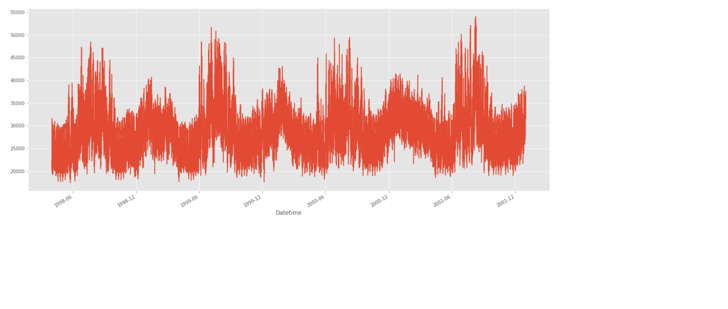

**Conclusion:**

Measuring and managing energy consumption is crucial for achieving sustainability, cost-efficiency, and environmental responsibility. An effective energy consumption measurement project leverages innovative technologies and strategies to gather and analyze data, identifies opportunities for improvement, and implements measures to reduce energy usage.

**Submitted by:**

**S K YASWANTH PRABHU**

**au711221104068**